Introduction

This document is a brief explanation of the Active Non Active application (ANA). It is also designed as an installation guide as well.
The principal for this application is to monitor the uDeploy servers in an Active Non Active setup.
If the active server goes down for any reason then the non active server within 5 seconds (this time interval can be change in the configuration file) will become the active server.

Installation files

There are two packages in form of tar balls that are needed for installation.
- nonActivePackage.tar – This package needs to be untarred on a server that will have the non active uDeploy server process (ready to be activated) in a directory under the control of the uDeploy account.
- ActivePackage.tar – This package needs to be installed in any location on the active uDeploy server process machine.

What the packages contain and how to configure for different servers

nonActivePackage.tar

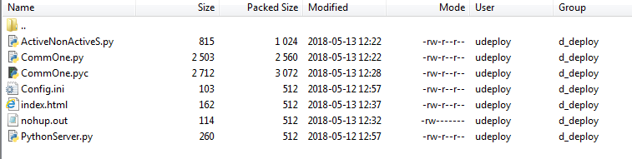

The only file that is needed for configuration is Config.ini as shown below:
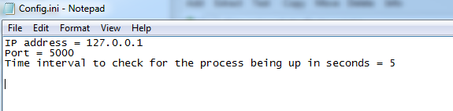

The IP address the first row remains the same for all situations.
Port number can be changed as needed but please remember this port number as the Active Package needs to have the similar change.
Time interval the last line is the interval of time in seconds that the application monitors to see whether the uDeploy application is up or down.

ActivePackage.tar

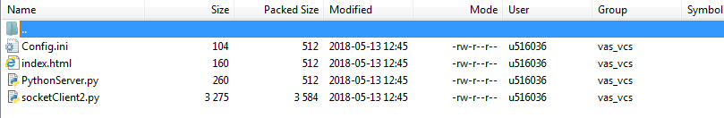
The only file that is needed for configuration is Config.ini as shown below:
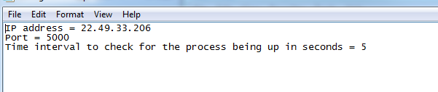

The IP address is the IP address of the non active server
Port should be the same post as entered for the non active server Config.ini file.
Time interval is the interval of time in seconds that the uDeploy server process is being monitored.

How to run and monitor the package

Both packages include two files PythonServer.py and index.html. The server file is a very light weight web service that exposes the index.html file via a web browser.
This is the first part of the run process on either server; issue the following command:
nohup python PythonServer.py > /dev/null 2>&1 &
Point your browser to the server that the command was issued and put in the name of the server as shown below:

Please note the port number after the server name, 8000.
This internal http communication takes place on port 8000. This is not configurable for this version of the package.
After issuing the above command please start by logging into the active server.

Please make sure that the uDeploy server process is up.
Navigate to the folder that the Active package was untarred and issue the following command:
nohup python socketClient2.py &
As shown below:
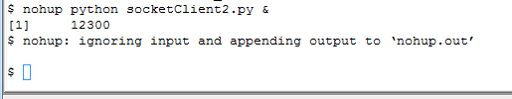

Please login to the non active server and SU to udeploy account
Please make sure that the udeploy process is NOT up and if it is up please stop the process.
Navigate to the location of the Non active package and issue the following command:
nohup python ActiveNonActiveS.py &
As shown below:
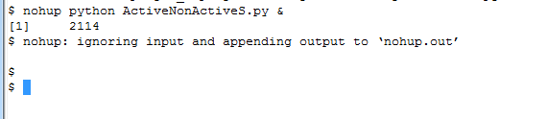

Should the process fail on the active server within 5 seconds the non active server becomes active. Verify this by point your browser to it to verify that it has become active?
Once the previously active server has been examined and fixed, please make sure that the udeploy server is down on the previously non active server and now active server and start both processes up in order that was explained above. Once the hand off occurs the active non active processes need to be restarted for the next handoff although the python server monitoring does not have to be restarted.

